Computer Security

Dept. of Computer Engineering

Chulalongkorn University

Activity XIII : Privacy

Instructors : Kunwadee Sripanidkulchai, Ph.D.

# Overview

In this activity, we will practice our forensics analysis skills to see what private information we can pull from photos.

# Part I: Photo Meta-Data

A lot of information is easily embedded in photos, such as GPS coordinates.

Download this photo: https://goo.gl/XtHkMH

Use any tool of your choice to find out what meta-data information is included in the photo. Answer the following questions.

1. Where was the photo taken?   
   256 Kings Rd, Brighton BN2 1TD, United Kingdom  
   Using windows Photos application and google map  
   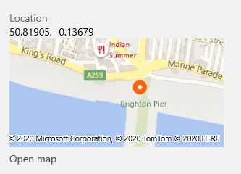
2. What other meta-data information is included with the photo? Describe which meta-data information can be used for forensics, and how.   
   - Device and lens can help identify photo taker  
   - Date taken can help identify photo taker and well, identify date taken  
   - File name look somewhat generated this information could be use to identify the program created it.
3. Upload the photo to facebook. Does facebook know where the picture was taken?   
   No, but friends that comment on the photo do.
4. If someone were to download it from facebook after your post above, would they know where it was taken? Why?   
   No, because the meta data about the location is gone.
5. Modify the picture on your computer (crop, resize, etc.). Does the location information disappear? If not, find a way to remove the meta-data information from the photos. Describe how you removed it and upload it.   
   No, I use Windows built-in option.  
   Uploaded at: https://drive.google.com/file/d/1N-cBu-XmHbSxG0AI7ObUjbFL9M30zJw5/view?usp=sharing  
   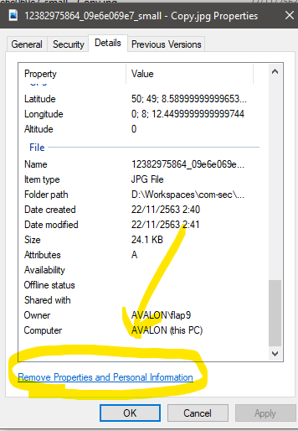
6. Is it a good idea to have location information in photos? Discuss the security/privacy implications.   
   Yes, because it benefits normal usage, photographer work and forensic. Even though these information can be exploit, to remove the meta data is not hard and is performed automatically upon uploading to many application like facebook.
7. If you do not wish to have this information recorded in your photos in the first place, what do you need to do?   
   Depends on device, here is for iPhone camera.  
   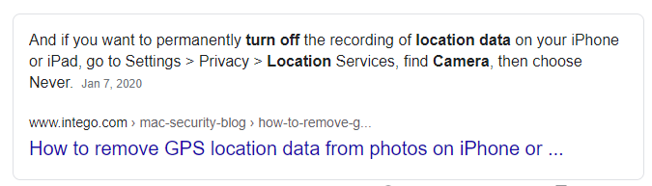
8. Did you check your own mobile phone settings? What will you do from today onwards? Will you share your location information with any app?

Yes, it currently uses location information. I will leave it as it is since it’s useful. Sharing location information is another thing which I take it quite seriously.